Introducing Dose – A Tribute To The Grateful Dead

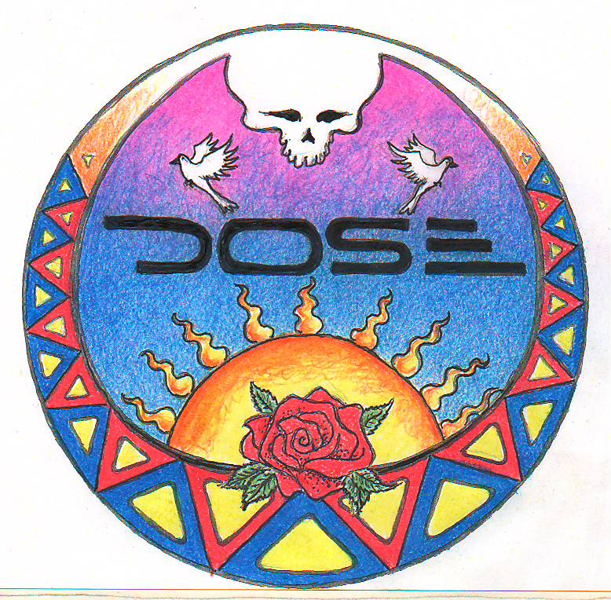

To explore the art of music through the prism of Grateful Dead ideology, and ultimately to carry on the good vibe that they bestowed upon us.

Dose is a west suburban Chicago based Grateful Dead Tribute band. We feel honored to be able to play the Dead’s music, while infusing our own passion, soul and intensity. Our approach is very much in the tradition of creating spontaneous improvisational jams. We use the Grateful Dead’s music as a launching pad for our own synergistic ensemble playing.

The band has been practicing and playing gigs in the Chicago area for five years. Mike Kramer (lead guitar) found John Goldthwaite (rhythm guitar) via a west side musician’s networking group. We are now proud and honored to have Dale Woods as our bassist and Chris Abbs occupying the drum throne.

The following is a brief bio of each member.

Mike Kramer – lead guitar and vocals:
Mike has been playing guitar for many years and saw the Dead over 50 times. Completely self taught, he has developed a unique style and really isn’t a Jerry Garcia imitator. To the untrained ear, he sounds an awful lot like Jerry, but serious deadheads will know that he’s not just up there copping licks. Mike had local success in the 1990’s with his Grateful Dead inspired band named New Speedway Boogie. They opened for Melvin Seals and the Jerry Garcia Band in 98 and were featured on the Sundog tv showcase out of Madison,WI. All the band’s artwork is done by Mike as well.

John Goldthwaite – rhythm guitar and vocals:
John is also totally self taught and a 50 show veteran who has been playing guitar for over 20 years. He has been in eight bands, spanning 15 years most of whom did at least a few Grateful Dead songs. His sweet tone and tasteful rhythms gel perfectly with the rest of the band. John also writes and produces original music as a side project.

Dale Woods – bass:
Dale is a true seasoned musician of playing Grateful Dead music. He's been playing bass for 30 years, is a founding member of Hairball Willy and has played in numerous jam bands through the decades. Dale has spent many years honing his craft and if you close your eyes you might think you were listening to Phil Lesh!

Chris Abbs – drums:
Chris is a relative newcomer to Grateful Dead music. He's been playing drums for six years, and has infused Dose with his unique approach and influences. Chris started playing in ska bands in high school, then in a more electronic band, Earnest Nellis. He's recently found the jam scene to be much more to his liking and is really having fun with the chance to improvise more. He's got some great jazz and latin chops that really add an individual flavor to our sound.

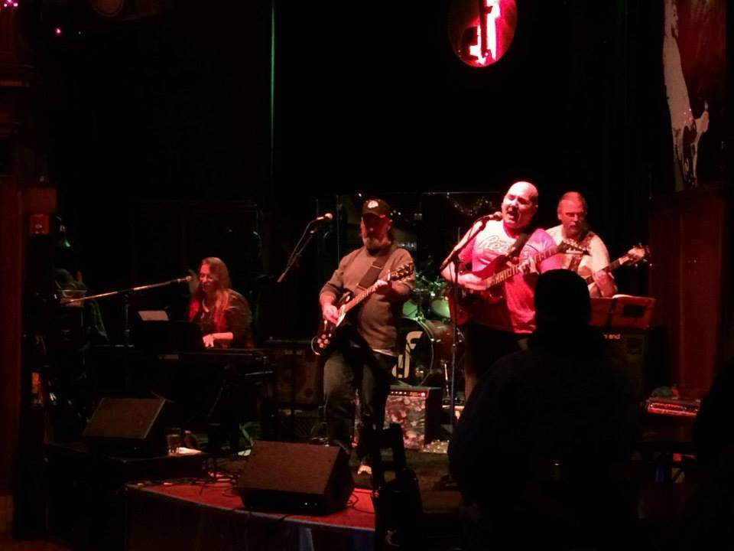

Link To Music Samples – all demo material recorded live Spring of 2014

http://gizard.org/goother/Dose-Demo/

Dose at Miss Kitty's Saloon Naperville,IL April 2016
https://www.youtube.com/watch?v=WGhQRmQyrxs

Dose at The Grateful Garcia Gathering August 3rd 2012
http://www.youtube.com/watch?v=kAjFbHsYJcQ&feature=youtu.be

Booking Contact Information
https://www.facebook.com/dosewithus

Please feel free to contact either of us for additional information or booking discussion.
We pride ourselves on being responsive and professional.

John Goldthwaite
goother@comcast.net
Home phone 630-590-5250
Cell phone 262-242-1489

Mike Kramer
Mikekramer1965@hotmail.com
Cell phone 630-815-5060

